Fractured Illusions Revisited

Published By:
PintGlassGames

Developed By:
PintGlassGames

Revision: 0.0.1

Document History

Version | Date | Summary | Author(s)
0.0.1 | 10/07/2024 | Initial Draft | PintGlassGames

Document History
Game Summary
Target Platform(s)
Business Model
Game Overview
Theme / Setting / Genre
Core Gameplay Mechanics
Story and Gameplay
Story
Core Gameplay
User Interface
Main Menu
Gameplay Screen
How To Play Screen
Credits Screen
Game Completed Screen
Game Over Screen
Level Design Tools
First Time Experience

Game Summary

- Fractured Illusions Revisited is a remake of the same game now being developed in Unreal Engine 4 with its original vision, it will be more in depth than the original release.

- 3D First Person horror game

- Set in a hospital

- Game will have jump scares

- Game will have puzzles

- Player will only have flashlight

- Player will have an objective to gather evidence by collecting notes/journals

- Player will be unable to fight, they will have to avoid enemies

- There will be an item inventory and health system

Target Platform(s)
- Xbox Series X

Business Model
This game is planned to be released on the Xbox Series X currently.

Game Overview

Theme / Setting / Genre
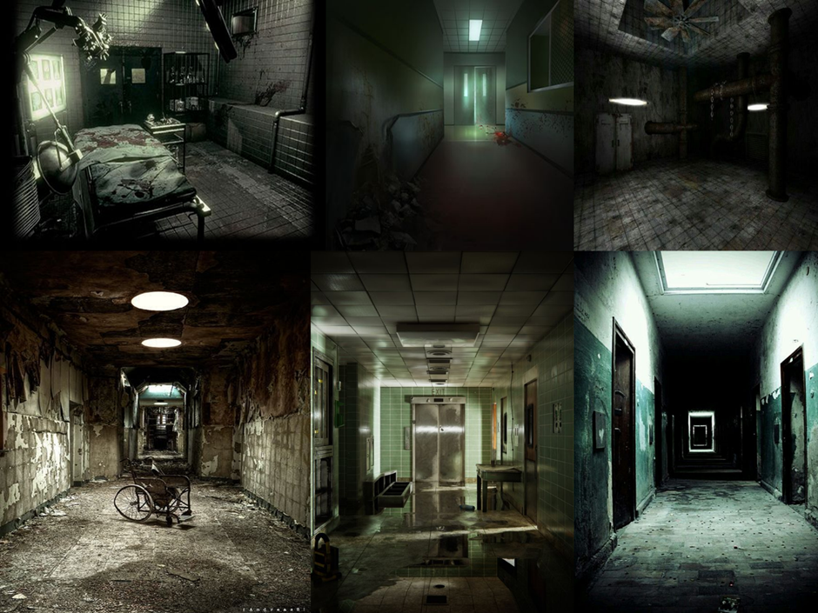

Core Gameplay Mechanics

- This game takes its inspiration from the likes of Outlast, Resident Evil, Silent Hill and Layers of Fear series.

Story and Gameplay

Story
You are Patient0042, you have been taken by a mysterious group and have woken up in an abandoned hospital feeling the effects of some sort of experiment with the hospital appearing to be eerily quiet the player will have to explore the hospital with just a flashlight. The player’s main task is to find collectibles such as notes/journals in order to uncover what is happening and find a way to escape.

Core Gameplay
Encounter enemy?

Escape

Solve Puzzles

Core Loop
Enter Room
Explore
Find notes/documents
Unlock
New Room

User Interface

Main Menu
- Game Logo
- “Play Now” Button - Goes to 2. Gameplay Screen
- “How To Play” - Goes to 3. How To Play
- “Credits”- Goes to 4. Credits

Gameplay Screen
Generic screenshot of the gameplay

How to Play Screen
Will show controller and its inputs.

Credits Screen
Will display credits for the game

Game Completed Screen
Will display a congratulations and thanks for playing message upon completion.

Game Over Screen
Will display thanks for playing message upon death

Level Design Tools
Game will be created entirely with Unreal Engine 4 with 3D models being created with Maya.

First Time Experience
The first room in this game that the player wakes up in will be treated as a short tutorial room where the aim of the game is explained as well as all of the controller inputs. With this the health and inventory system will also be explained along all of this collecting items and solving puzzles will be explained. The player will have to complete tutorial steps in order to escape the first room in order to continue. The aim of this tutorial is to give the player the rundown of inputs, systems and how to progress along with the overall objective of the game to get to the end.

